You are given a positive integer n representing the number of nodes in a **connected undirected graph** containing **exactly one** cycle. The nodes are numbered from 0 to n - 1 (**inclusive**).

You are also given a 2D integer array edges, where edges[i] = [node1i, node2i] denotes that there is a **bidirectional** edge connecting node1i and node2i in the graph.

The distance between two nodes a and b is defined to be the **minimum** number of edges that are needed to go from a to b.

Return *an integer array answer* *of size* n*, where* answer[i] *is the* ***minimum*** *distance between the* ith *node and* ***any*** *node in the cycle.*

**Example 1:**

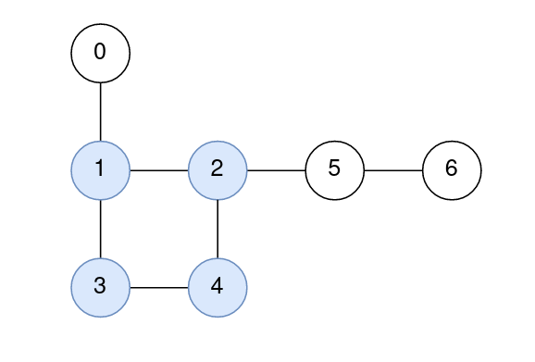

Input: n = 7, edges = [[1,2],[2,4],[4,3],[3,1],[0,1],[5,2],[6,5]]  
Output: [1,0,0,0,0,1,2]  
Explanation:  
The nodes 1, 2, 3, and 4 form the cycle.  
The distance from 0 to 1 is 1.  
The distance from 1 to 1 is 0.  
The distance from 2 to 2 is 0.  
The distance from 3 to 3 is 0.  
The distance from 4 to 4 is 0.  
The distance from 5 to 2 is 1.  
The distance from 6 to 2 is 2.

**Example 2:**

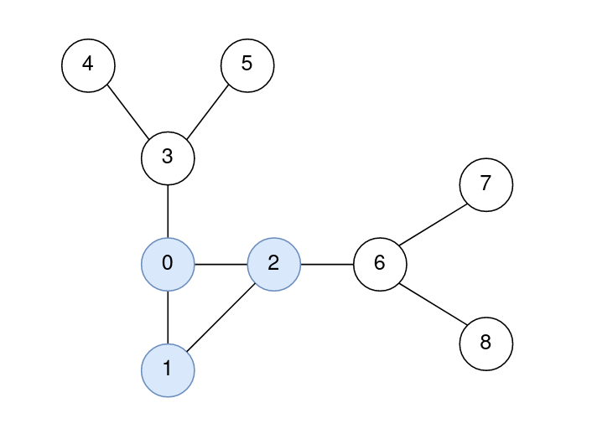

Input: n = 9, edges = [[0,1],[1,2],[0,2],[2,6],[6,7],[6,8],[0,3],[3,4],[3,5]]  
Output: [0,0,0,1,2,2,1,2,2]  
Explanation:  
The nodes 0, 1, and 2 form the cycle.  
The distance from 0 to 0 is 0.  
The distance from 1 to 1 is 0.  
The distance from 2 to 2 is 0.  
The distance from 3 to 1 is 1.  
The distance from 4 to 1 is 2.  
The distance from 5 to 1 is 2.  
The distance from 6 to 2 is 1.  
The distance from 7 to 2 is 2.  
The distance from 8 to 2 is 2.

**Constraints:**

* 3 <= n <= 105
* edges.length == n
* edges[i].length == 2
* 0 <= node1i, node2i <= n - 1
* node1i != node2i
* The graph is connected.
* The graph has exactly one cycle.
* There is at most one edge between any pair of vertices.